Maginot Line

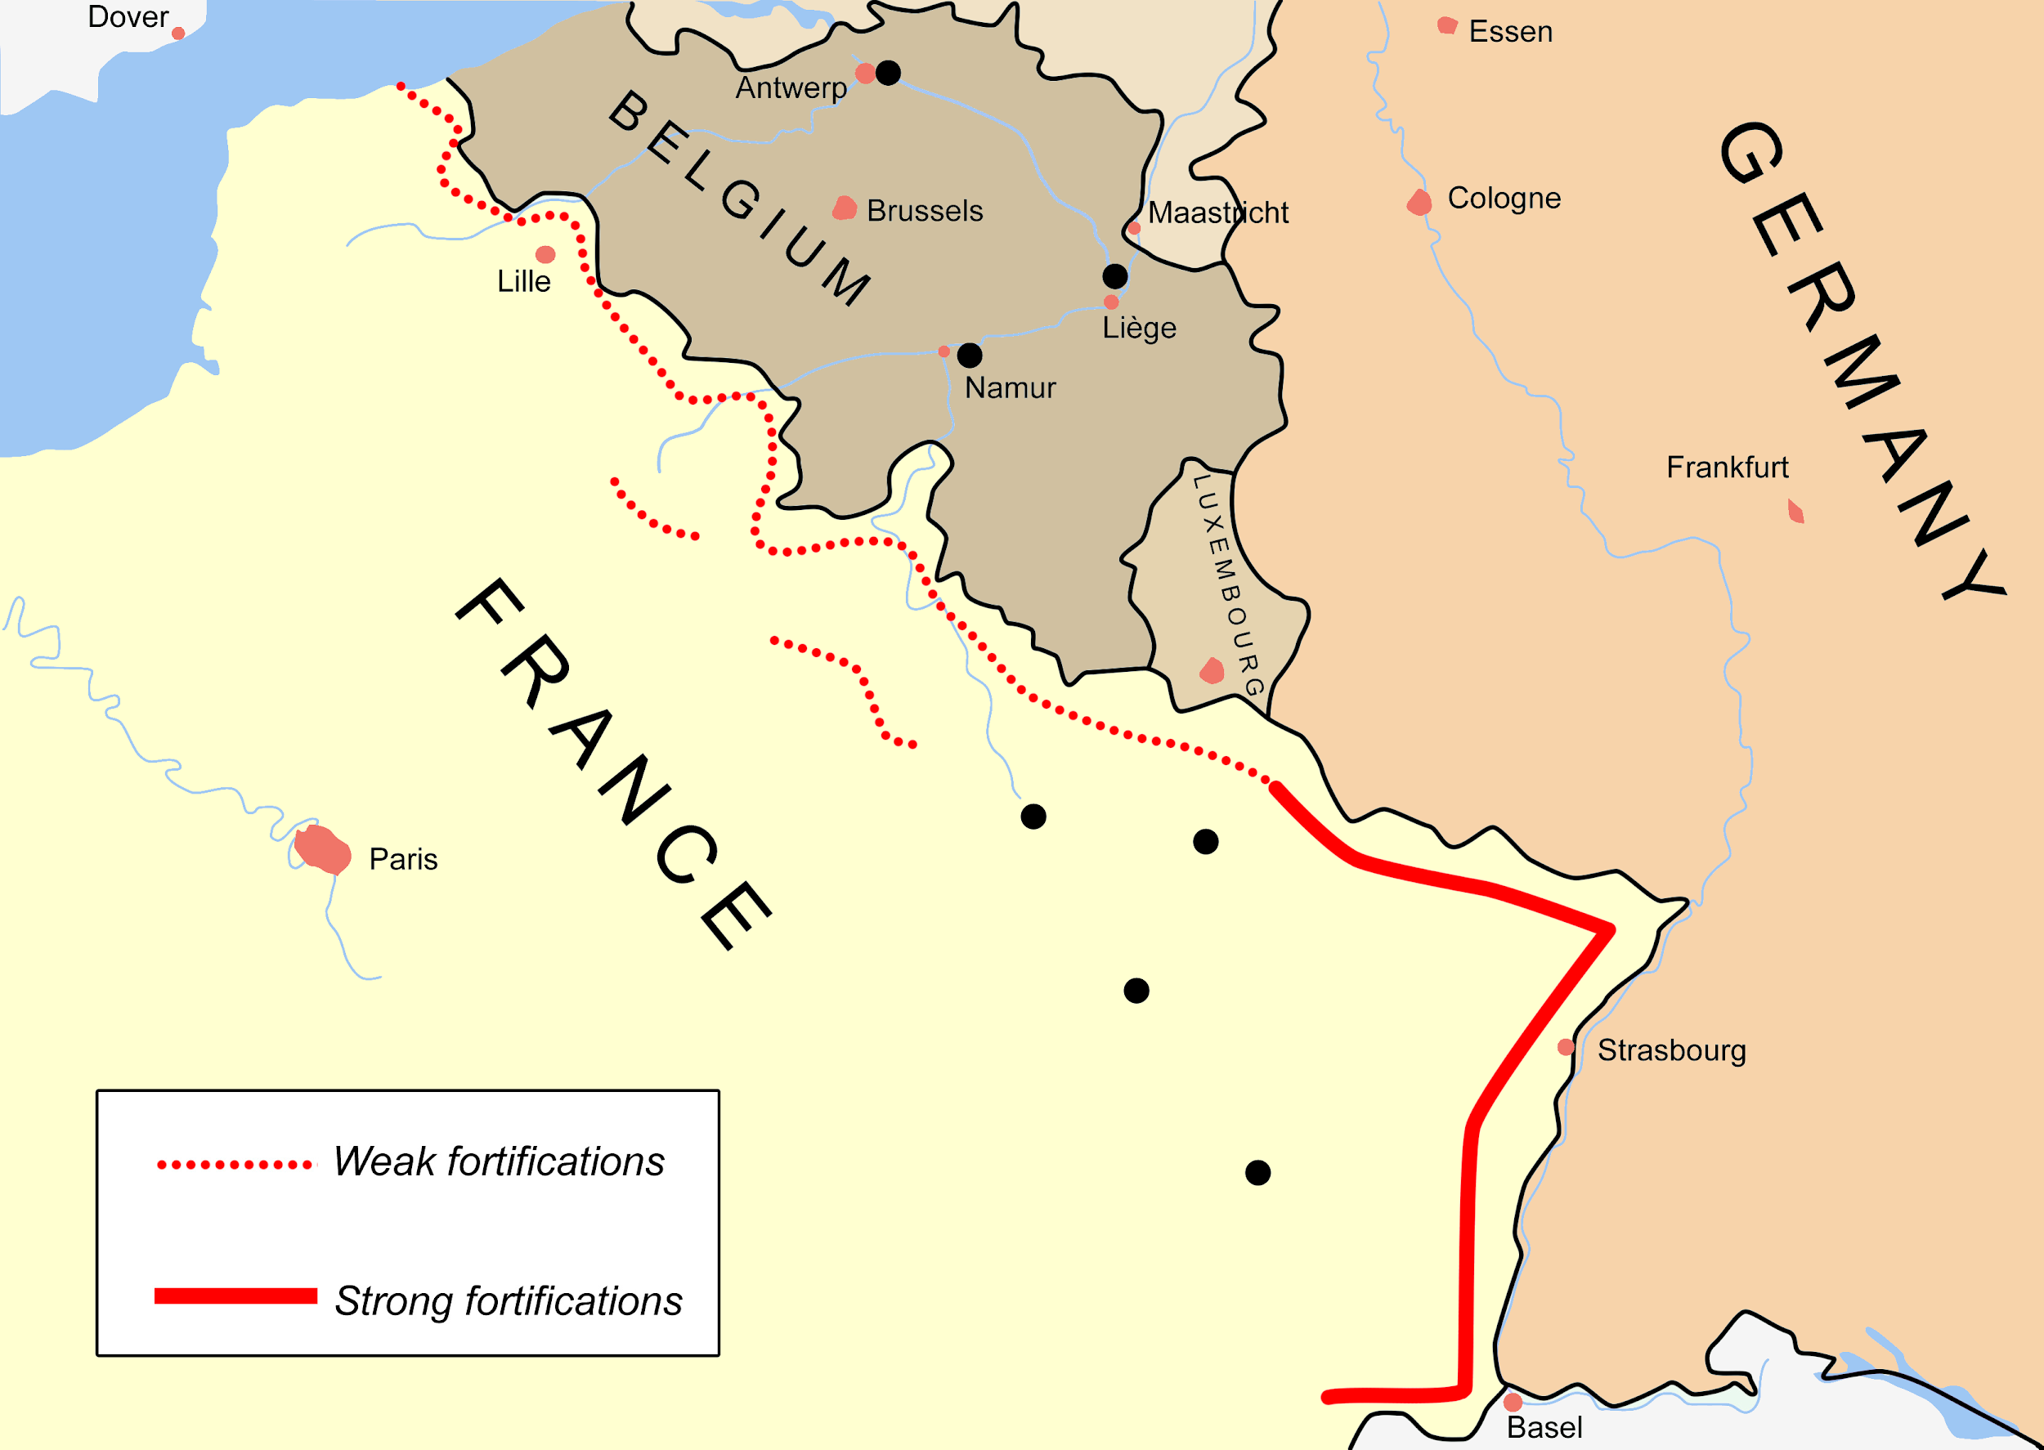

1. What do you think the Maginot Line was for? ______________________________________________________________________
2. In what country do you find the Maginot Line? _______________
3. What three countries border the Maginot Line? _______________, _______________ & ______________
4. Where is the line of defence the strongest? ______________________
5. Find 2 pictures of the Maginot Line fortifications and attach them below?